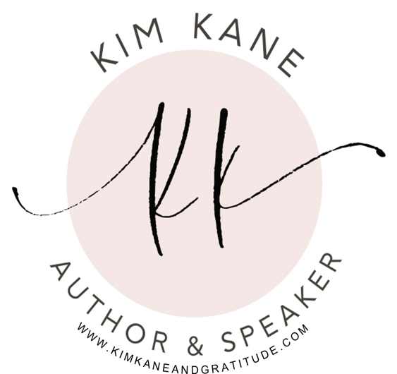

About Kim…
Kim Kane is a retired educator; serving over 34 years. In addition, Kim is a national trainer/presenter on a variety of topics including; education, chemical dependency, stress reduction, mindfulness practices, and most recently she is focused on living authentically as we age.

Kim entertains and informs many all around the world. Her mix of stories, both humorous and tender-hearted, help to create the sense that you are in her living room having a personal conversation over a cup of coffee, or more often than not, a glass of wine. After interviewing over 200 people about aging, she took ordinary experiences and created stories filled with extraordinary learning and moments of gratitude for everyday living. She put it all together and created her award-winning book: Sparkle On…Women Aging in Gratitude. In addition to this book, she is one of the authors in the anthology book: Her Path Forward.

In addition, she is a Transitional Life Coach; helping women to navigate through transitional times as they age. Kim is the host of the podcast: Oatmeal, Pearls and Bourbon; a podcast on healthy living, pearls of wisdom and a toast to life!

Most importantly, Kim enjoys being with her husband, Pat, her grown children, spouses and better yet, her grandchildren! What joy!

All of this together represents her belief it is never too late to do and to be whatever it is you desire!

