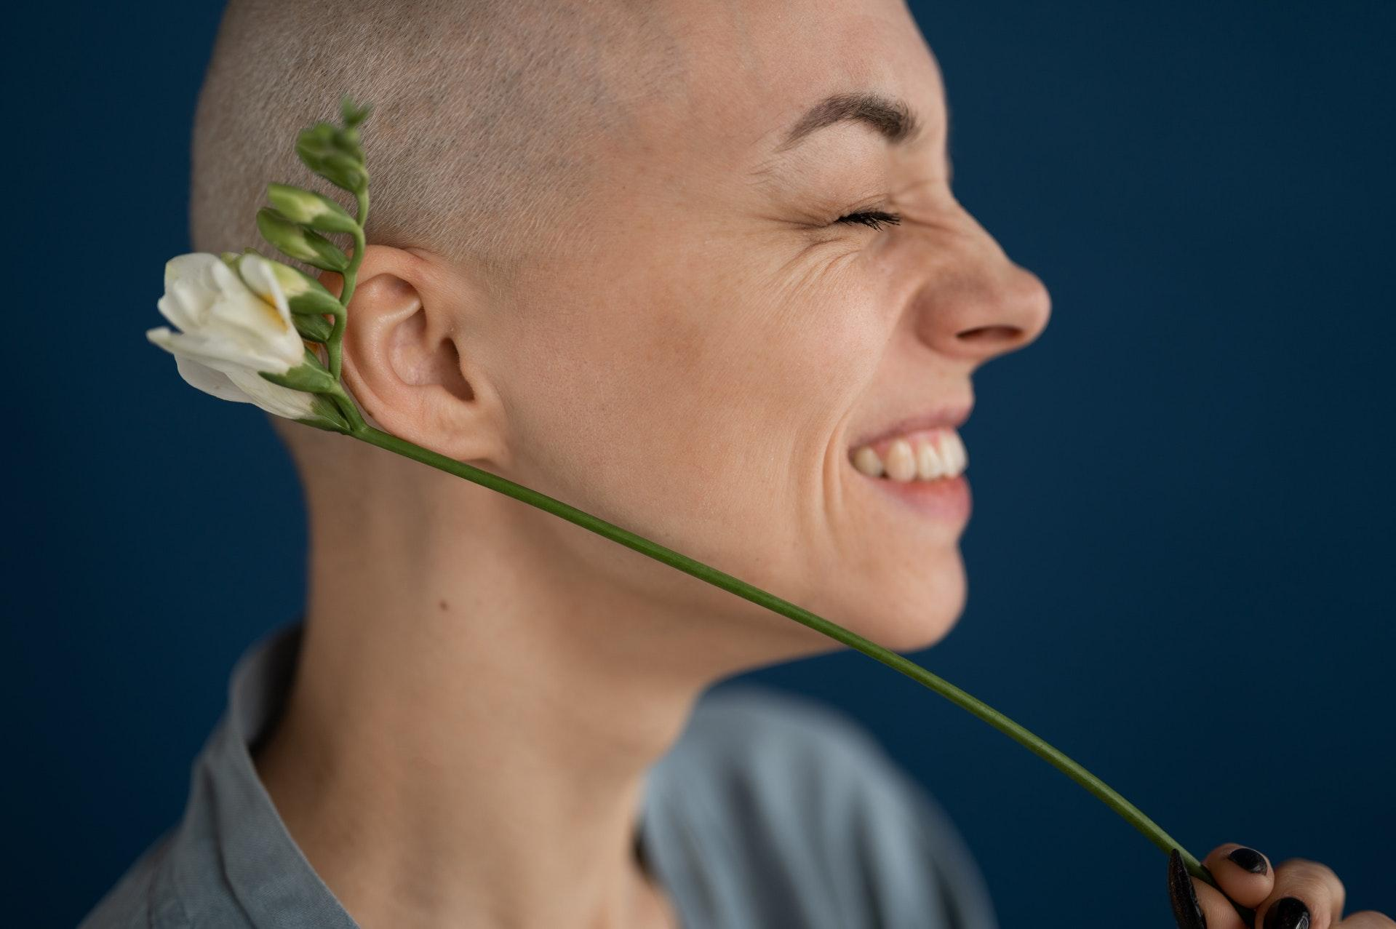

Image via [Pexels](https://www.pexels.com/photo/crop-smiling-woman-with-blooming-freesia-and-closed-eyes-6984608/)

How to Improve the Lives of People With Cancer (When You’re Not a Doctor)

Study after study has revealed that cancer patients are better equipped to adjust their lives when they have strong emotional and practical support. And you don’t have to be a doctor or a scientist to make a difference in the life of someone with cancer. Whether it’s starting your own organization, volunteering for an existing organization, or simply being a good friend, there are many ways to get involved. Below, writer, Kimberly Hayes expands on these ideas and more.

**Launch a Nonprofit**

One of the boldest steps you could take to help people with cancer is to start your own nonprofit organization. Launching a cancer nonprofit will certainly be challenging, but it will be easier to qualify for public funding and grants as a nonprofit corporation.

Setting up such a corporation will require you to [create bylaws that outline](https://www.zenbusiness.com/nonprofit-corp/) the rules under which your organization will operate. Your bylaws will need to detail your voting process, how you will handle conflicts of interest, the frequency with which your board of directors will meet, how your organization will be governed, and more. If you need help learning the ins and outs of establishing a nonprofit corporation, look to online formation services.

**Become a Volunteer**

Another way to support cancer patients and survivors is to volunteer for an existing organization dedicated to cancer research. See if there are any local charities where you can give your time and energy each week or month.

If that’s not an option, research the [various national organizations](https://donorbox.org/nonprofit-blog/top-cancer-charities) you can volunteer for or donate to on a recurring basis. Here are some of the leading cancer charities in the country:

* [American Cancer Society](https://www.cancer.org/involved/volunteer.html) (ACS)
* American Institute for Cancer Research (AICR)
* LIVESTRONG
* Gilda's Club/Cancer Support Community
* Susan G. Koman for the Cure
* Leukemia and Lymphoma Society

Another option can be organizing an awareness walk for cancer research. When planning such an event, one important consideration is determining the route of the walk. This is where [a Walk Score map](https://www.redfin.com/how-walk-score-works) can be particularly helpful. With this tool, you can identify the most pedestrian-friendly streets and pathways in the area, ensuring that participants have a safe and enjoyable experience. Additionally, Walk Score maps can help to identify points of interest along the route, such as parks or other landmarks. This can not only make the walk more engaging for participants, but also provide opportunities for rest or refreshment.

**Explore Alternative Treatments**

Health and wellness professionals constantly research and experiment with alternative treatments to help cancer patients [lead better lives](https://www.mayoclinic.org/tests-procedures/cancer-treatment/in-depth/cancer-treatment/art-20047246). Becoming a practitioner or teacher of such treatments could be a fulfilling and effective method of helping people with cancer in your community and beyond. Here are a few treatments worth considering:

* Exercise
* Meditation
* Music therapy
* Massage therapy
* [Cognitive Behavioral Therapy](https://www.annalsofoncology.org/article/S0923-7534(19)35403-1/fulltext) (CBT)
* Aromatherapy
* Acupuncture
* Yoga

**Be a Friend**

Lastly, if you know someone with cancer, [being a true friend](https://styleblueprint.com/everyday/how-to-be-a-good-friend-to-someone-with-cancer/) to them can do wonders for improving their life. Many cancer patients lose contact with close friends and even relatives, and it's typically because the friend or relative doesn't know how to communicate with them. But the truth is that most cancer patients are not looking for people to say the right thing or provide the perfect service.

Be sure to keep up with your friend through notes, text messages, and/or regular calls. If possible, pay your friend regular in-person visits just to talk or engage in fun activities. Even a video call now and then can make a big difference. The important thing is that you are present, listening, and open to talking about whatever.

And, of course, many cancer patients struggle to complete daily tasks around the house. Offer to help clean inside ([with carcinogen-free cleaners](https://cleanerdigs.com/the-top-rated-carcinogen-free-cleaning-products/)), mow the lawn, repair the leaky faucet, or handle any other home maintenance tasks. Furthermore, consider having your friend’s home evaluated for any modifications that could help them live more safely and comfortably.

If your heart is telling you to help someone (or multiple people) living with cancer, you have plenty of options. Consider starting your own cancer nonprofit or becoming a volunteer at a local or national organization. Look into various alternative treatments professionals are using to treat patients, and consider practicing or teaching a specialty. Lastly, simply be a good friend by keeping in contact, offering to handle household tasks, and doing anything else that can help the cancer patient lead a happier life.

*For women 50+ seeking help with challenging transitions, contact* [*transitional coach Kim Kane*](https://www.kimkaneandgratitude.com/) *today!*